SYLLABUS TILL 31st MAY, 2016
NUR E.M.
GK: Introduction of colours, fruits, animals and flowers (five each). Ability to recognise these objects (original and picture) and tell their names in English, understanding skills. To respond to the commands as come here, sit down, stand up, keep quite, touch your eyes/ head/ feet/ nose/ mouth, practice by action.

ENGLISH: Introduction of colours, parts of body, oral A B C D, writing skill strokes, vertical downwards vertical upwards, slanting, slanting upwards, horizontal left to right

COLOURING
SKILLS: To recognise red, green, blue, black and white colours

RHYMES: Twinkle twinkle little star.

MATHS: Counting of solid objects. (only 5 objects)

SYLLABUS TILL 31st MAY, 2016
LKG

GK: Name of five each. Parents to provide chart or picture books for vegetables, fruits, birds, animals, means of transports, colours of functions/ use of the objects in question. For example- show a picture of a bus and ask what is it? A bus, now discuss its parts as wheel, round in shape, body , window, window screen, mirror, seat, driver, we use it for travelling, going from one place to another.
Shape- round, square, triangle, kite.

ENGLISH: Revision of letter of alphabet, oral and written, dictation, cursive stroke, start with c then d, c, d, a. English conversation, respond to commands as open your book at page….. write down, listen to me, keep quite, come, go out, clap your hand,

HINDI: Start with vyanjan ([k] d x Ä) and not with swar
[k] d x Ä igPkkuuk

MATHS: Introduction to ones and ten, what comes before, what comes after etc. circle the bigger number, circle the smaller number counting of objects up to 20 concrete objects, addition of 1 as 2+1, 3+1, 4+1, say 2 and 1=3, 2+1=3

URDU: Introduction of the following letters.

Shapes one but different by dot.

ISLAMIC STD: First kalimah with English version.

SYLLABUS TILL 31st MAY, 2016
UKG

GK: Means of transport, national flag, symbols, places of worship, indoor games, calls of the wild animals i.e. match the animals with the sounds they make. Tools and equipments to work as-
axe- woodcutter
stethoscope- doctor
screwdriver- electrician etc.

ENGLISH: Correcting the spelling of miss spelt words, fill in the blanks
with is, am, are, a, an, this, that, these, those, he, she, I, we, you, they, in, on, with, between etc as taught during the teaching of structure. Answering the simple questions in a complete sentence as-
Ques. 1) What is your name?
Ans. My name is ………
Ques. 2) What is this?
Ans. This is a book.
ORAL: At least five rhymes/poems, name of major parts of body, fruits, flowers, birds, animals, pets.
HINDI: Revision of two and three letter words.
Eg, cl] ty] ix] gy and uxj] Qly] dey] ped reading, writing and dictation.
MATHS: Lesson 1 to 3
- Numbers up to 100
- Addition up to 20
- Subtraction up to 20
Tables of 2, 3 and 4, spelling up to 40, revision, dictation concept of 5>3, 6<9, 2=2, concept of ones and tens.

EVS: After introduction of family, class room and animals, start first of all, I want to introduce my self, my family, my food, healthy body, reading and all exercises complete it, oral questions, quiz like what type of family do you live in? What do we call a family of four members?

SYLLABUS TILL 31st MAY, 2016
I E.M.

GK: 1. Animal’s babies. 2. Who eats what? 3. Animal sounds. 4.What do we get? 5. Moving about.
Name of five friuts, flowers, birds, animals. Parts of some bird’s and animal’s body. Some articles of daily usage like spoon, cup, saucer, bowl, plate etc.
ENGLISH: First three lessons, reading with meaning and dictation, some action words, opposite words eg. Long- short, day- night, light- heavy, left- right, correct- incorrect, up- down etc.
Oral practice-
What is this/it? What are these/those? Who are you? What is the name of your school? What is your father’s name? Where do you live? What are you doing?
HINDI:
MATHS: Numbers up to 200, addition of three digit numbers without carry, subtraction of three digit numbers without borrowing,
ascending and descending order, introduction to place value
URDU: 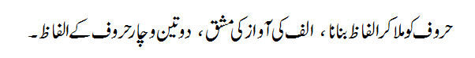

SYLLABUS TILL 31st MAY, 2016
II E.M.
EVS: Chapter 1 to 4 with question & answer, fill in the blanks, true- false, name these and match the columns

ENGLISH: READING WRITING AND COMPREHENSION
Text book as prescribed by the school. Various exercises as contained in the text book based on comprehension, language, development, spelling and applied grammar,
Ability to give answer by reading the given paragraph and finding the answer.
Introduction of noun, pronoun and verb.
COMPOSITION
Ability to write five or ten sentences on very simple topics as rose, dog, horse, cow, school, my parents, my self using words to make sentences

GK: Page no. 5 to 12.

ART: To draw a design in a square, rectangle and in a circle. To draw fruits and colour it.

MATHS: Numbers name, after & before, ascending and descending order, geometric shapes, numbers from 100-1000, write in numerals form, write in words, write the missing number, after before & between numbers, what is long, what is round, counting in groups.

URDU:

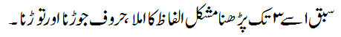

ARABIC:
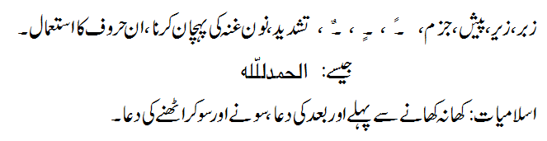

SYLLABUS TILL 31st MAY, 2016
III E.M.

COMPUTER: Chapter 1 and practical.

ENGLISH: Unit 1 to 3.

ENGLISH
GRAMMAR: Parts of speech. (noun, pronoun, verb)
GK: Lesson 1

EVS: Lesson 1 to 4.

MATHS: Unit 1 to 3

HINDI:    

URDU:

ARABIC:
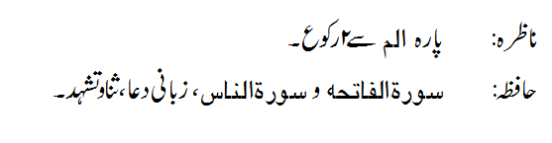

SYLLABUS TILL 31st MAY, 2016
IV E.M.

COMPUTER: Introduction to computer, learn to use MS-Windows XP.

ENGLISH: Unit 1 to 3.

ENGLISH
GRAMMAR: Parts of speech. (noun, pronoun, verb)

GK: Unit 1 (Flora and Fauna)

EVS: Lesson 1 to 4.

MATHS: Hindu Arabic Numeration System, Natural numbers, Whole numbers, Even & Odd numbers, Large numbers in Indian system like Thousands & Lakhs, numbers definition, conversion from words to numerals and from numerals to words, mathematical operations + ,− , × , ÷
Addition, Addends, sum, subtraction, minuend, subtrahend, difference, statement based problems on addition & subtraction.

HINDI:    

URDU:

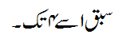

ARABIC:
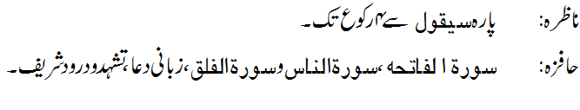

SYLLABUS TILL 31st MAY, 2016
V E.M.

COMPUTER: Lesson 1 & 2. Practical.

ENGLISH: Lesson 1 to 3.

ENGLISH
GRAMMAR: Parts of speech, Chapter 1 & 2.
GK: Lesson 1 to 4

EVS: Lesson 1 to 3.

MATHS: 1. Large numbers
a. Comparing and ordering large numbers
b. International system of writing numbers.
2. Operation on large numbers
a. Addition c. multiplication
b. Subtraction d. division
3. Order of operation
BODMAS
HINDI:    
: ➢ □○

URDU:
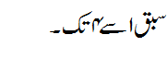
ARABIC:

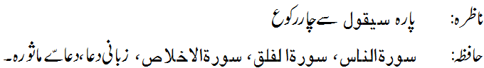

SYLLABUS TILL 31st MAY, 2016

VI E.M.

COMPUTER: 1. Introduction to computer.
2. More on MS Windows.

ENGLISH: Lesson 1 to 3.

ENGLISH
GRAMMAR: Antonyms, synonyms, give one word for, homophones. Essay: Science is a good servant but a bad master, uses of electricity
SOCIAL
SCIENCE: Geography:
- Earth in the solar system
- Globe: Latitudes and Longitudes
History:
- What, Where, How and When
- On the trail of the earliest people
Civics:
- Understanding diversity
- Diversity and discrimination

SCIENCE: BIOLOGY:
- Food: Where does it comes from
- Components of food
SCIENCE:
- Fibre to fabric
MATHS: Hindu Arabic Numeration System, Natural numbers, Whole numbers, Even & Odd numbers, Prime & Composite numbers, Large numbers in Indian system like Thousands Lakhs Crores & Arabs, International system like millions, billions & trillions, definition, conversion from words to numerals and from numerals to words. Mathematical operations +, −, ×, ÷
Addition, Addends, sum, subtraction, minuend, subtrahend, difference, statement based problems on addition & subtraction.

HINDI:   

: ➢

URDU:
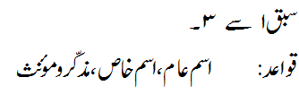

SYLLABUS TILL 31st MAY, 2016
VII E.M.

COMPUTER: 1. Introduction to computer.
2. More on MS Windows.

ENGLISH: Lesson 1 to 3.

ENGLISH
GRAMMAR: Interchange of sentences (affirmative, negative, interrogative and exclamatory) Narration (Assertive and Interrogative), antonyms and synonyms.

SOCIAL
SCIENCE: Geography:
- Environment
- Inside our Earth
History:
- Tracing changes through thousand years
- New kings and kingdoms
Civics:
- On equality
- Role of government in health

SCIENCE: BIOLOGY:
Chapter 1 to 3.
SCIENCE:
Chapter 4, 5 & 6
MATHS: Basic information about Mathematics, concept of Integers, classification, number line, integers on a number line, ordering, properties on Integers, closure property, commutative, Associative property and distributive property. Operation with Integers. Addition, Subtraction, Multiplication and Division of Integers.
Fractions and decimals, Operations with fractions, Addition, Subtraction, Multiplication and Division of fractions, Operation with decimals, Addition, Subtraction, Multiplication and Division with Decimals, statement based problems on fractions and decimals.

HINDI:   
    

URDU:
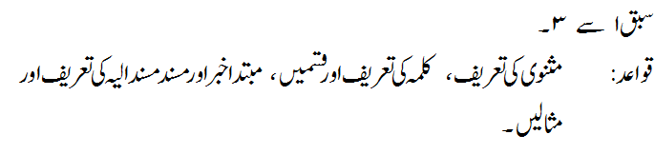

SYLLABUS TILL 31st MAY, 2016
VIII E.M.

COMPUTER: 1. Introduction to computer.
2. More on MS Windows.

ENGLISH: Lesson 1 to 3.

ENGLISH
GRAMMAR: Interchange of sentences (affirmative, negative, interrogative and exclamatory) Narration (Assertive and Interrogative), antonyms and synonyms.

SOCIAL
SCIENCE: Geography:
- Resources
- Land, Soil, Water, natural vegetation and wild life resources
History:
- How, When and Where
- From trade to territory
Civics:
- The Indian Constitution
- Understanding secularism

SCIENCE: BIOLOGY:
Crop production and management
Micro-organism: Friend and foe
SCIENCE:

MATHS: Chapter 1 and 2

HINDI: LESSON 1 TO 4

URDU:
